**BINARY TO DECIMAL CONVERSION:**

**EXP NO:26**

**AIM:**To write a C program to implement binary-to-decimal conversion.

**APPARATUS:** DEV C++

**ALGORITHM:**

1)      Start  
2)      Read the binary number from the user, say ‘n’  
3)      Initialize the decimal number, d=0  
4)      Initialize i=0  
5)      Repeat while n != 0:                                                               
i.     Extract the last digit by remainder = n % 10                                                             
ii.     n = n/10                                                           
iii.     d = d + (remainder * 2<sup>i</sup>)                                                      
iv.     Increment I by 1  
6)      Display the decimal number, d  
7)      Stop

**PROGRAM:**

#include<stdio.h>  
void main()   
{   
    int num, binary_num, decimal_num = 0, base= 1, rem;   
    printf (" Enter a binary number with the combination of 0s and 1s \n");   
    scanf (" %d", &num);  
    binary_num = num;  
    while ( num > 0)   
{   
  rem = num % 10;  
 decimal_num = decimal_num + rem *base;   
 num = num / 10;   
 base = base * 2;   
}  
  printf ( " The binary number is %d\t", binary_num);  
  printf (" \n The decimal number is %d\t", decimal_num);     
}

**INPUT:**

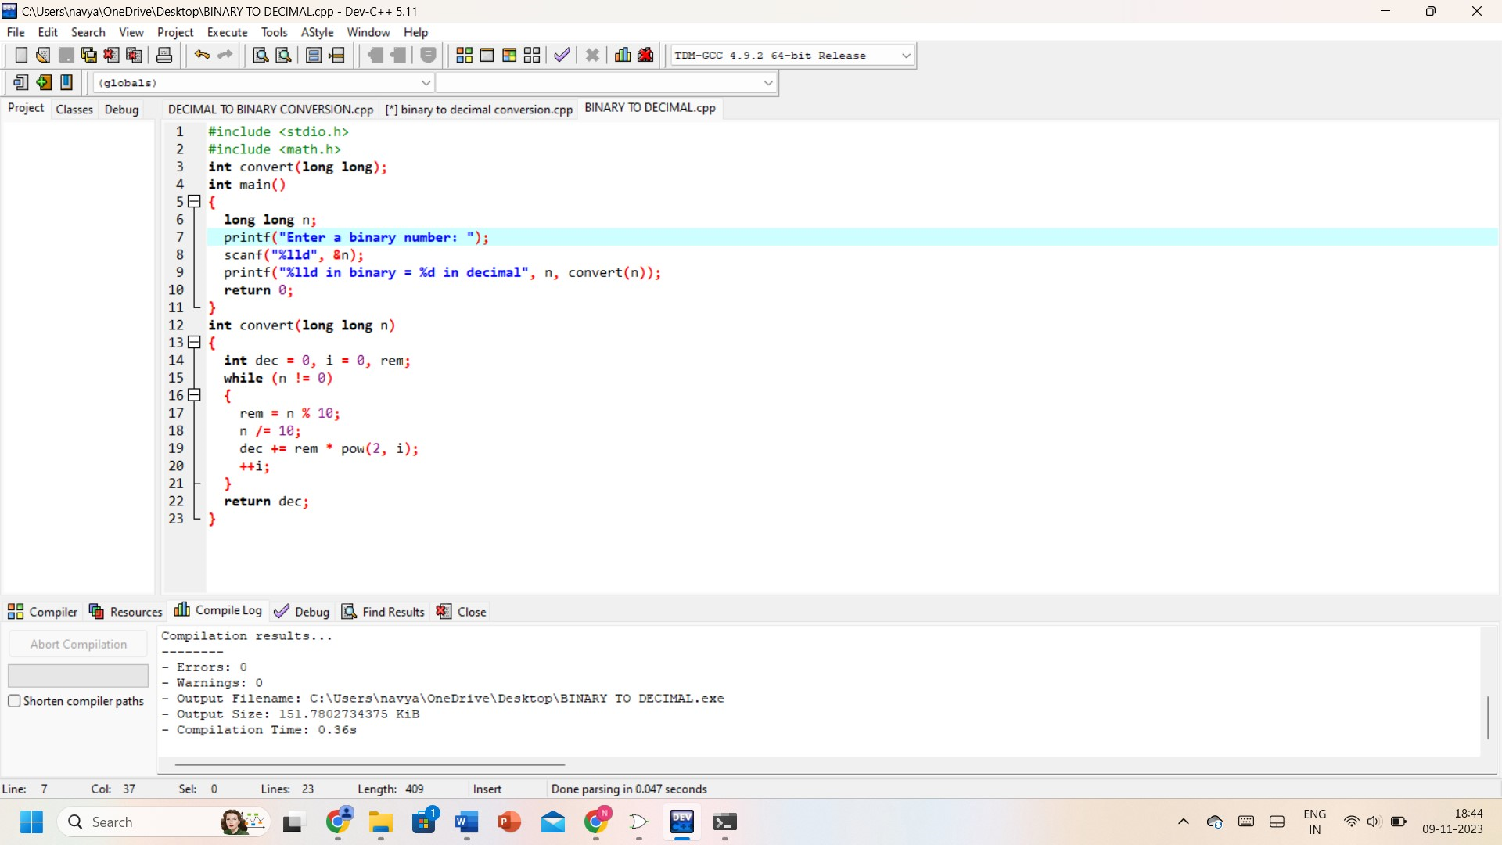

**OUTPUT:**

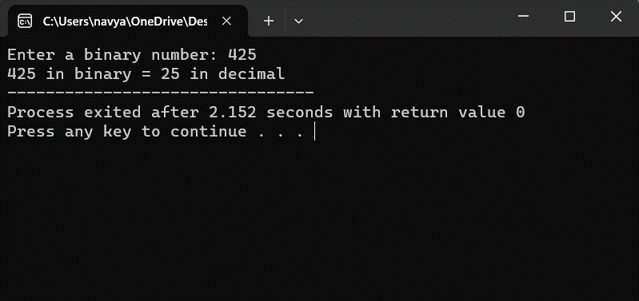

**RESULT:** Thus, the program was executed successfully using DevC++.